1 run...

training 1 epoch...

173.43935298919678 seconds used......

1 training finished! average train loss: 0.6153039268963585

evaluating...

Confusion matrix, without normalization

[[ 66 471 485]

[ 39 4808 560]

[ 18 266 10481]]

Normalized confusion matrix

[[0.06457926 0.46086106 0.47455969]

[0.00721287 0.88921768 0.10356945]

[0.00167209 0.02470971 0.97361821]]

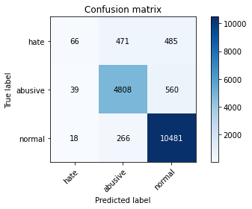

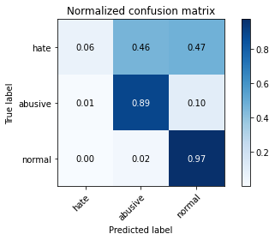

precision recall f1-score support

hate 0.54 0.06 0.12 1022

abusive 0.87 0.89 0.88 5407

normal 0.91 0.97 0.94 10765

accuracy 0.89 17194

macro avg 0.77 0.64 0.64 17194

weighted avg 0.87 0.89 0.87 17194

average eval_loss: 0.3715546715831341, accuracy: 0.8930440851459811

training 2 epoch...

173.4192283153534 seconds used......

2 training finished! average train loss: 0.41772130880876285

evaluating...

Confusion matrix, without normalization

[[ 289 370 363]

[ 222 4850 335]

[ 118 405 10242]]

Normalized confusion matrix

[[0.28277886 0.36203523 0.35518591]

[0.04105789 0.89698539 0.06195672]

[0.01096145 0.03762192 0.95141663]]

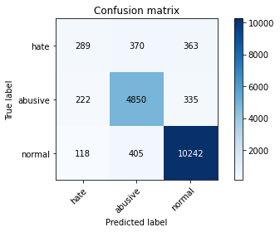

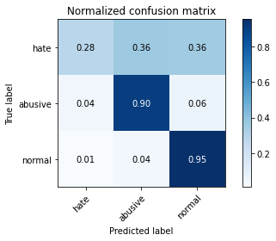

precision recall f1-score support

hate 0.46 0.28 0.35 1022

abusive 0.86 0.90 0.88 5407

normal 0.94 0.95 0.94 10765

accuracy 0.89 17194

macro avg 0.75 0.71 0.72 17194

weighted avg 0.88 0.89 0.89 17194

average eval_loss: 0.3445367884237406, accuracy: 0.8945562405490287

training 3 epoch...

173.53873991966248 seconds used......

3 training finished! average train loss: 0.3386001209154878

evaluating...

Confusion matrix, without normalization

[[ 410 305 307]

[ 435 4714 258]

[ 401 260 10104]]

Normalized confusion matrix

[[0.40117417 0.29843444 0.30039139]

[0.08045127 0.87183281 0.04771592]

[0.03725035 0.02415235 0.93859731]]

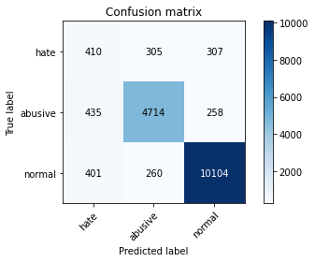

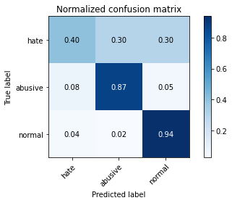

precision recall f1-score support

hate 0.33 0.40 0.36 1022

abusive 0.89 0.87 0.88 5407

normal 0.95 0.94 0.94 10765

accuracy 0.89 17194

macro avg 0.72 0.74 0.73 17194

weighted avg 0.89 0.89 0.89 17194

average eval_loss: 0.35126624924758837, accuracy: 0.8856577876003257

training 4 epoch...

Confusion matrix, without normalization

[[ 393 303 326]

[ 303 4767 337]

[ 318 331 10116]]

Normalized confusion matrix

[[0.38454012 0.2964775 0.31898239]

[0.05603847 0.88163492 0.06232661]

[0.02954018 0.03074779 0.93971203]]

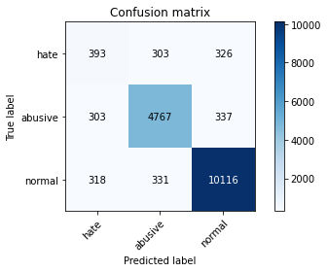

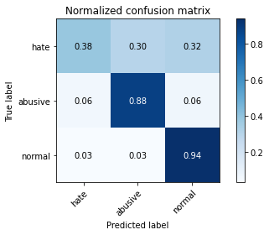

precision recall f1-score support

hate 0.39 0.38 0.39 1022

abusive 0.88 0.88 0.88 5407

normal 0.94 0.94 0.94 10765

accuracy 0.89 17194

macro avg 0.74 0.74 0.74 17194

weighted avg 0.89 0.89 0.89 17194

average eval_loss: 0.3538429592627772, accuracy: 0.8884494591136443

training 5 epoch...

173.95334577560425 seconds used......

5 training finished! average train loss: 0.1927430701969175

evaluating...

Confusion matrix, without normalization

[[ 474 294 254]

[ 463 4698 246]

[ 783 430 9552]]

Normalized confusion matrix

[[0.46379648 0.28767123 0.24853229]

[0.08562974 0.86887368 0.04549658]

[0.07273572 0.03994426 0.88732002]]

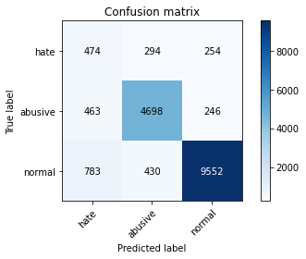

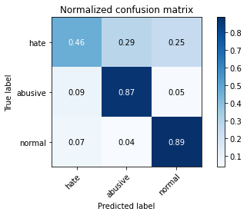

precision recall f1-score support

hate 0.28 0.46 0.35 1022

abusive 0.87 0.87 0.87 5407

normal 0.95 0.89 0.92 10765

accuracy 0.86 17194

macro avg 0.70 0.74 0.71 17194

weighted avg 0.88 0.86 0.87 17194

average eval_loss: 0.45408730302006006, accuracy: 0.8563452367104804

2 run...

training 1 epoch...

174.42926788330078 seconds used......

1 training finished! average train loss: 0.5963496584226746

evaluating...

Confusion matrix, without normalization

[[ 1 608 413]

[ 1 5060 346]

[ 1 622 10142]]

Normalized confusion matrix

[[9.78473581e-04 5.94911937e-01 4.04109589e-01]

[1.84945441e-04 9.35823932e-01 6.39911226e-02]

[9.28936368e-05 5.77798421e-02 9.42127264e-01]]

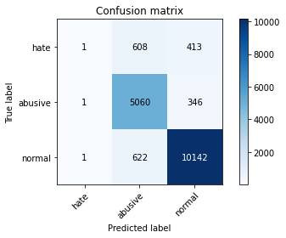

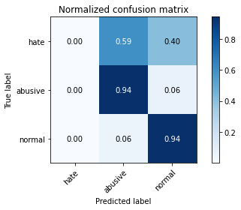

precision recall f1-score support

hate 0.33 0.00 0.00 1022

abusive 0.80 0.94 0.87 5407

normal 0.93 0.94 0.94 10765

accuracy 0.88 17194

macro avg 0.69 0.63 0.60 17194

weighted avg 0.86 0.88 0.86 17194

average eval_loss: 0.3965152320560328, accuracy: 0.8842037920204723

training 2 epoch...

174.20258331298828 seconds used......

2 training finished! average train loss: 0.3971261959058667

evaluating...

Confusion matrix, without normalization

[[ 282 319 421]

[ 239 4729 439]

[ 65 256 10444]]

Normalized confusion matrix

[[0.27592955 0.31213307 0.41193738]

[0.04420196 0.87460699 0.08119105]

[0.00603809 0.02378077 0.97018114]]

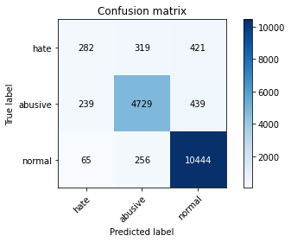

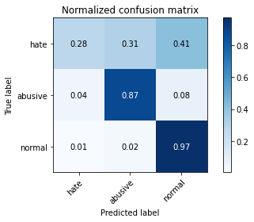

precision recall f1-score support

hate 0.48 0.28 0.35 1022

abusive 0.89 0.87 0.88 5407

normal 0.92 0.97 0.95 10765

accuracy 0.90 17194

macro avg 0.77 0.71 0.73 17194

weighted avg 0.89 0.90 0.89 17194

average eval_loss: 0.3277361737954062, accuracy: 0.8988600674653949

training 3 epoch...

174.22528100013733 seconds used......

3 training finished! average train loss: 0.32235266642967275

evaluating...

Confusion matrix, without normalization

[[ 252 368 402]

[ 151 4849 407]

[ 55 431 10279]]

Normalized confusion matrix

[[0.24657534 0.36007828 0.39334638]

[0.02792676 0.89680044 0.07527279]

[0.00510915 0.04003716 0.95485369]]

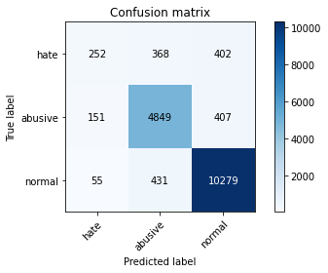

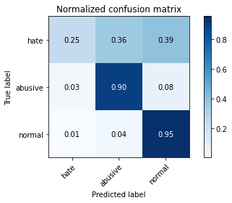

precision recall f1-score support

hate 0.55 0.25 0.34 1022

abusive 0.86 0.90 0.88 5407

normal 0.93 0.95 0.94 10765

accuracy 0.89 17194

macro avg 0.78 0.70 0.72 17194

weighted avg 0.88 0.89 0.89 17194

average eval_loss: 0.3453719660509811, accuracy: 0.8944980807258346

training 4 epoch...

174.10167598724365 seconds used......

4 training finished! average train loss: 0.2602424519792024

evaluating...

Confusion matrix, without normalization

[[ 309 410 303]

[ 162 4959 286]

[ 239 494 10032]]

Normalized confusion matrix

[[0.30234834 0.40117417 0.2964775 ]

[0.02996116 0.91714444 0.0528944 ]

[0.02220158 0.04588946 0.93190896]]

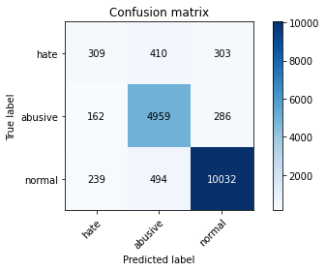

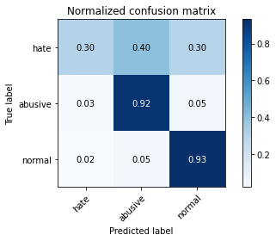

precision recall f1-score support

hate 0.44 0.30 0.36 1022

abusive 0.85 0.92 0.88 5407

normal 0.94 0.93 0.94 10765

accuracy 0.89 17194

macro avg 0.74 0.72 0.73 17194

weighted avg 0.88 0.89 0.89 17194

average eval_loss: 0.3649640634331072, accuracy: 0.8898452948703036

training 5 epoch...

174.1716456413269 seconds used......

5 training finished! average train loss: 0.17908052212962897

evaluating...

Confusion matrix, without normalization

[[ 419 309 294]

[ 383 4703 321]

[ 506 373 9886]]

Normalized confusion matrix

[[0.40998043 0.30234834 0.28767123]

[0.0708341 0.86979841 0.05936749]

[0.04700418 0.03464933 0.91834649]]

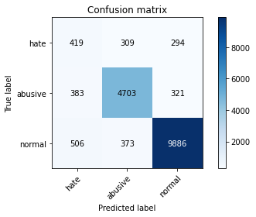

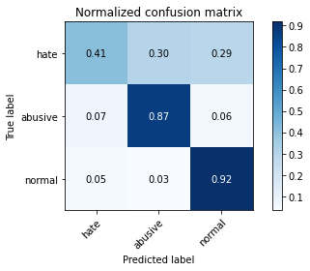

precision recall f1-score support

hate 0.32 0.41 0.36 1022

abusive 0.87 0.87 0.87 5407

normal 0.94 0.92 0.93 10765

accuracy 0.87 17194

macro avg 0.71 0.73 0.72 17194

weighted avg 0.88 0.87 0.88 17194

average eval_loss: 0.418564553727764, accuracy: 0.8728626264976155